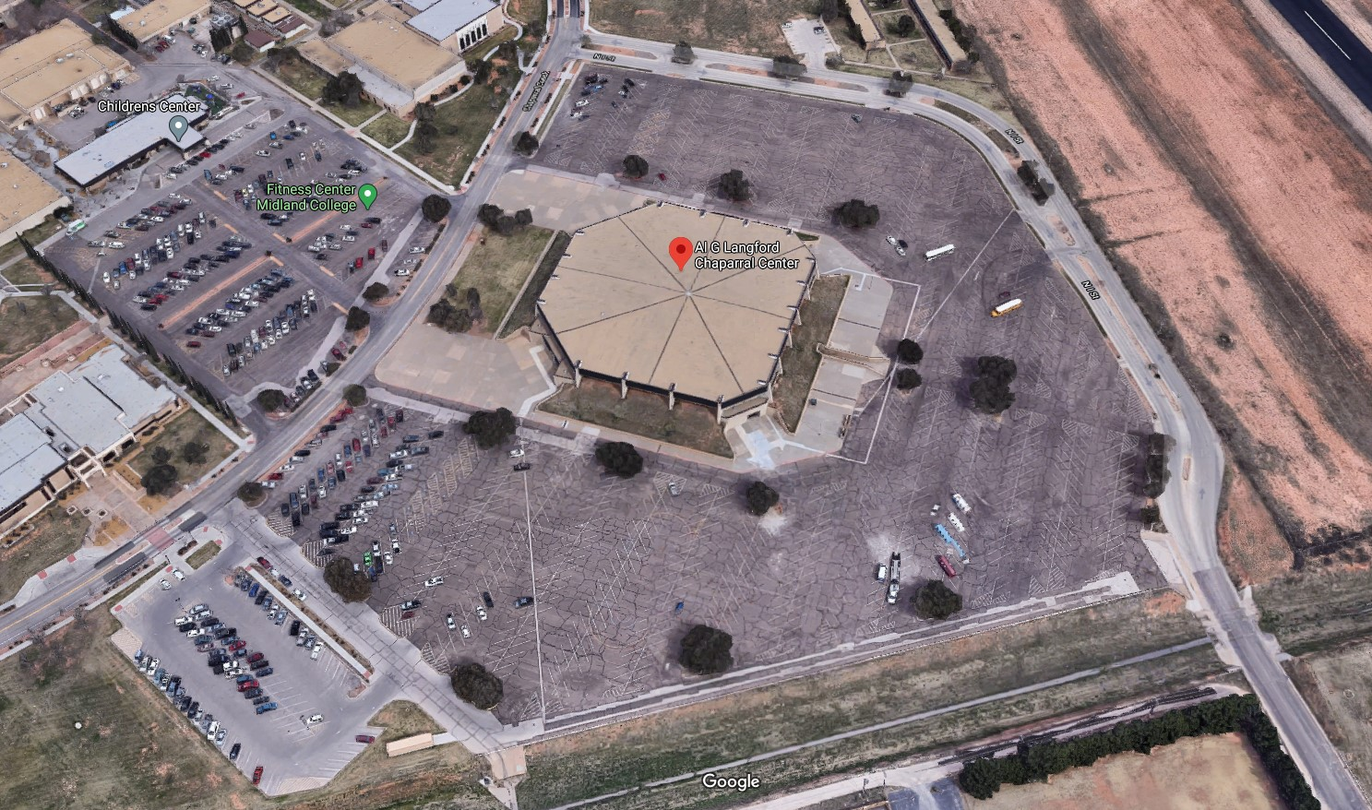
Recyclable Bins (Paper, Plastic, Aluminum, 2x Cardboard)
KMB Trailer/Sign In
Compactor
CMC, also appliances
Secured Shredding for electronics
Movable Cones
Cones & Tape
Volunteers
Greeters
Food Table
LEGEND
Door of Hope
Tires (State Rubber)
Open Top Roll off
Document Shredding
Donation Table
DOOR 4 – Restrooms Open

Volunteer Parking & Drop-Off
CCS Sign
CCS Sign

